Office use only
E: ___ PC:____ R:____ CC: ____

Name: _____________________________________________________ Date of Birth: _________________________
Address: __________________________________________________________________________________________
City: _________________________________ State: __________________ Zip Code: ________________________
Home Phone: ___________________________________ Work Phone: ____________________________________
Mobile Phone: __________________________________ Cell Phone Provider: _______________________________
Would you like to receive reminder text messages from ReJuvv’ Spa? Yes No
Email: ____________________________________________________________________________________________
Would you like to receive monthly emails & specials from ReJuvv’ Spa? Yes No
How did you hear about us? Facebook Radio Website Drive-by Billboard Friend
If referral, who can we send a thank you? ___________________________________________________________________________
Occupation: ___________________________
Emergency Contact (Name/Phone number/Relationship): _________________________________________________

Medical Information
- Are you currently under medical supervision? Yes No
If yes, please explain ________________________________ Physician Name: __________________________
- Do you see a chiropractor? Yes No
If yes, how often? __________________________________ Chiropractor Name: _______________________
- Are you currently taking any medication and/or vitamin supplements? Yes No
If yes, please list _____________________________________________________________________________
- Do you have any allergies or skin sensitivities? Yes No
If yes, please list _____________________________________________________________________________
- Have you had any traumatic accidents or operations? Yes No
If yes, please explain __________________________________________________________________________
- Do you have any heart conditions? Yes No
If yes, please explain __________________________________________________________________________
- Have you had a professional massage before? Yes No
If yes, how often do you receive massage therapy? _________________________________________________
- Is there a particular area of the body where you are experiencing tension, stiffness, pain or other discomfort? Yes No
If yes, please identify _________________________________________________________________________

Check ALL of the following conditions which you are experiencing.
This will help the therapist to tailor the massage to meet your needs.

Allergies | Cancer | Heart Condition | Joint Problems | Skin Problems
Anxiety | Cramping | High/Low Blood Pressure | Muscle Tension | Ticklishness
Arthritis | Depression | Infectious Condition | Phlebitis | Varicose Veins
Back Problems | Epilepsy | Inflammation | Pregnancy | Other
Blood Clots | Fatigue | Insomnia | Sciatica
Bruising | Headaches | Irritability | Sinus Problems

Further Explanation or Other Conditions:

Indicate with an X your present level of
Health | Poor__________________________________Good
Stress | Low High
Energy | Low High
Preferred pressure | Light__________________________________Firm

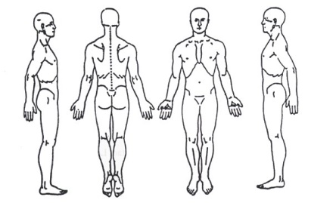
Note any Anatomical areas of tension, pain
or chronic distress on the diagram or describe

I, ______________________________ (print name) understand that the massage I receive is provided for the basic purpose of relaxation and relief of muscular tension. If I experience any pain or discomfort during this session, I will immediately inform the therapist so that the pressure and/or strokes may be adjusted to my level of comfort.
I further understand that massage should not be construed as a substitute for medical examination, diagnosis, or treatment and that I should see a physician, chiropractor or other qualified medical specialist for any mental or physical ailment that I am aware of.
I affirm that I have stated all my known medical conditions, and answered all questions honestly. I agree to keep the therapist updated as to any changes in my medical profile and understand that under no circumstance shall there be liability on the establishment, staff or therapist.
Signature of client ______________________________________________ Date __________________

Please be on time for your appointment or you will be charged for the full time we have set aside for you.
Anything considered odd behavior by the client during a massage will not be tolerated.
We require at least 24 hours in advance notice of any cancellation or you will be charged full service price.

